# ELEC 4727/5727 – Computer Vision Algorithms & Image Processing

Concept Review

**Fully Connected Neural (FCN) Networks**

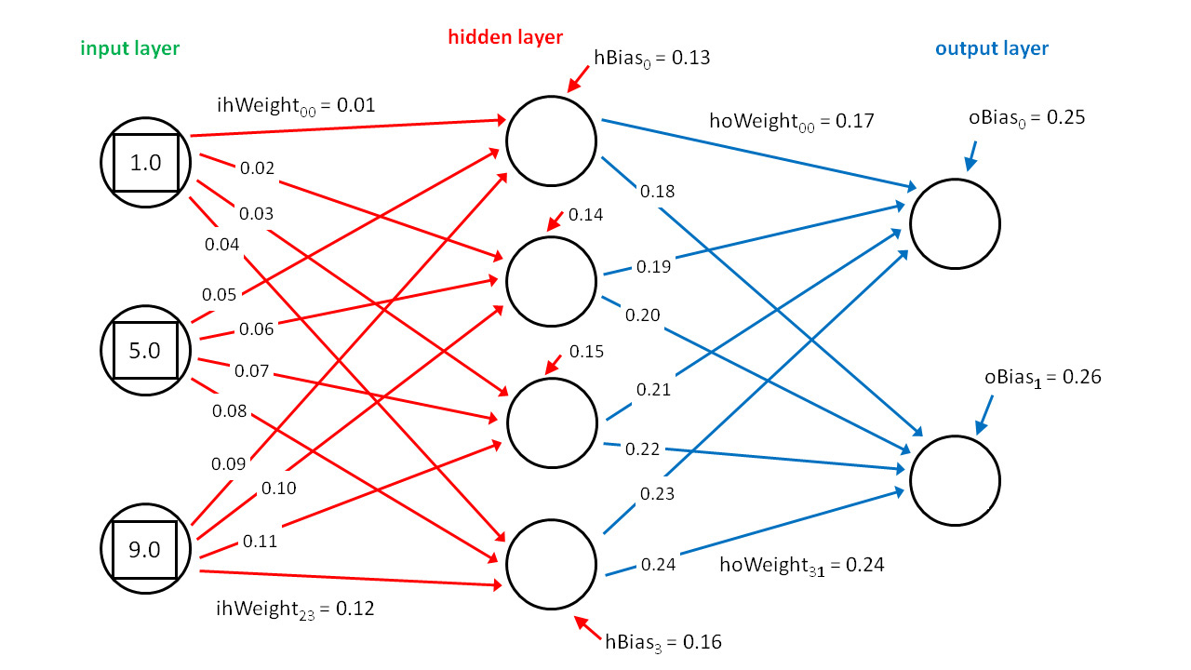

All Students:

The input values are {1.0, 5.0, 9.0}. The input-to-hidden weights are { 0.01, 0.02, . . 0.12 } and so on.

Perform two different evaluations of the network nodes using Sigmoid and ReLU at each node. The bias inputs to each node are shown.

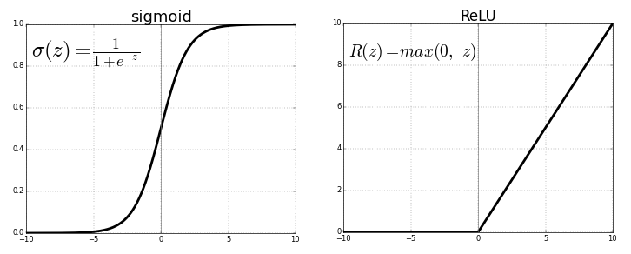

Show work, but fill out the table:

|  |  |  |  |  |  |  |
| --- | --- | --- | --- | --- | --- | --- |
|  | Hidden Layer | | | | Output Layer | |
|  | Node0 | Node1 | Node2 | Node3 | Node0 | Node1 |
| Sigmoid | (1*.01)+(5*.05)+(9*.09)+.13  = 1.2  Sigma = 1/(1+exp(-1.2)) = .768 | (1*.02)+(5*.06)+(9*.1)+.14 = 1.36  Sigma = 1/(1+exp(-1.36))  = .798 | (1*.03)+(5*.07)+(9*.11)+.15 = 1.52  Sigma = 1/(1+exp(-1.52))  = .820 | (1*.04)+(5*.08)+(9*.12)+.16 = 1.68  Sigma = 1/(1+exp(-1.68))  = .843 | (.768*.17)+(.798*.19)+(.82*.21)+(.843*.23)+.25 = .898  Sigma = 1/(1+exp(-.898))  = .710 | (.768*.18)+(.798*.2)+(.82*.22)+(.843*.24)+.26 = .941  Sigma = 1/(1+exp(-.941))  = .719 |
| ReLu | (1*.01)+(5*.05)+(9*.09)+.13  = 1.2 | (1*.02)+(5*.06)+(9*.1)+.14 = 1.36 | (1*.03)+(5*.07)+(9*.11)+.15 = 1.52 | (1*.04)+(5*.08)+(9*.12)+.16 = 1.68 | (.768*.17)+(.798*.19)+(.82*.21)+(.843*.23)+.25 = .898 | (.768*.18)+(.798*.2)+(.82*.22)+(.843*.24)+.26 = .941 |

Graduate students

Write and submit Python function for generating the results using Numpy from an input array for the above networks (use a parameter for selecting either Sigmoid or ReLu)